Home Page

Navbar

Logo

Login

Contact Us

Blog

Development +

Products

Website Development

UI/UX

Enterprise +

Digital +

Website Content +

Email Marketing

SEO FOR ENTERPRISE

Search Engine Marketing (SEM)

Social Media Marketing (SMM)

Search Engine Optimization (SEO)

Video Production

Marketing Designs

Website Content

Note : Here + sign Represents Dropdown in the Navbar

**Product Page**

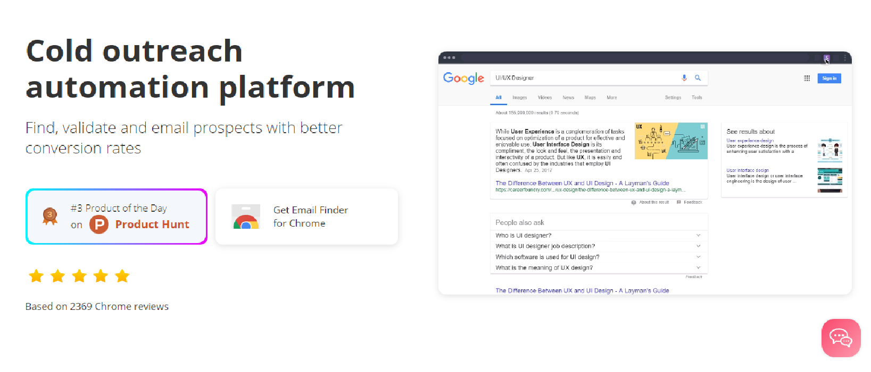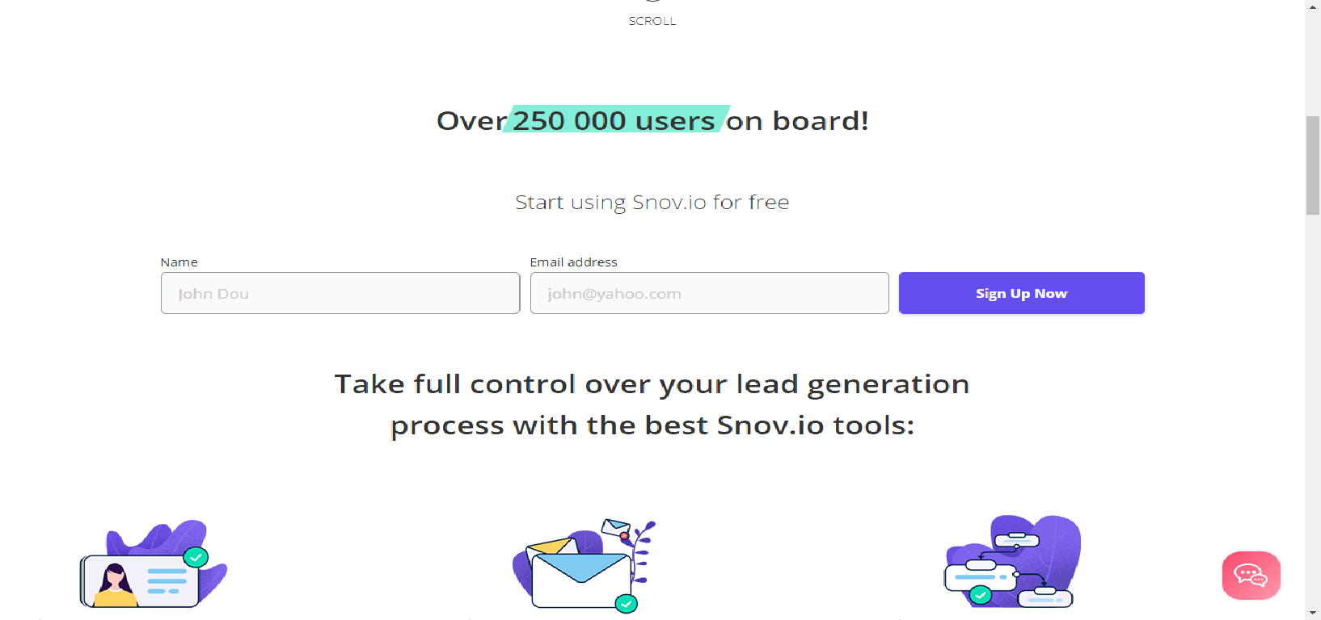

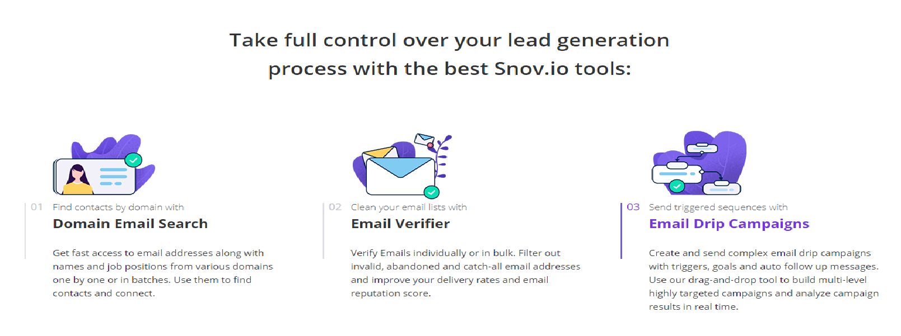

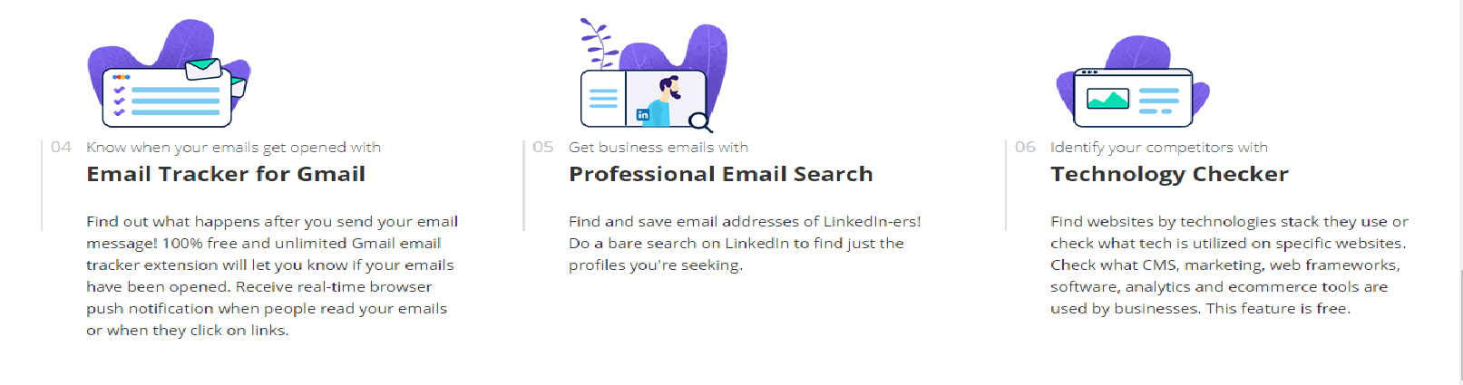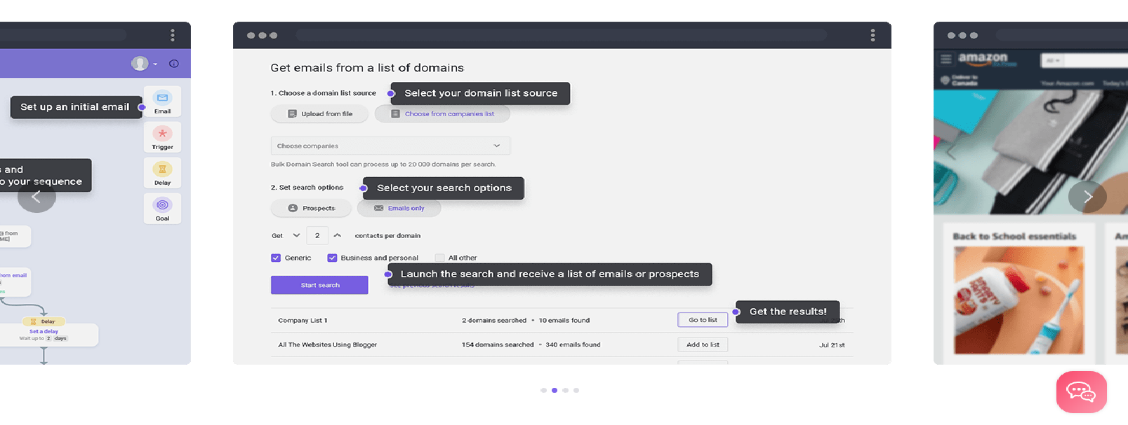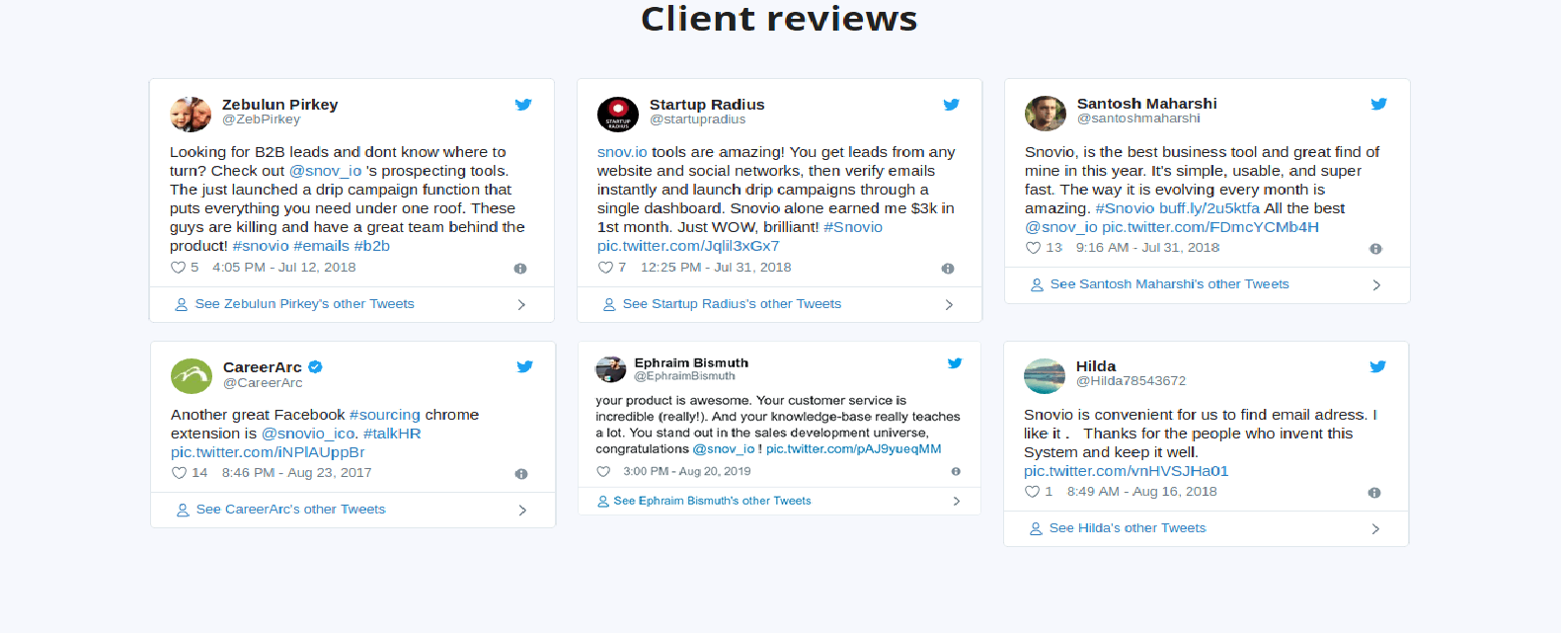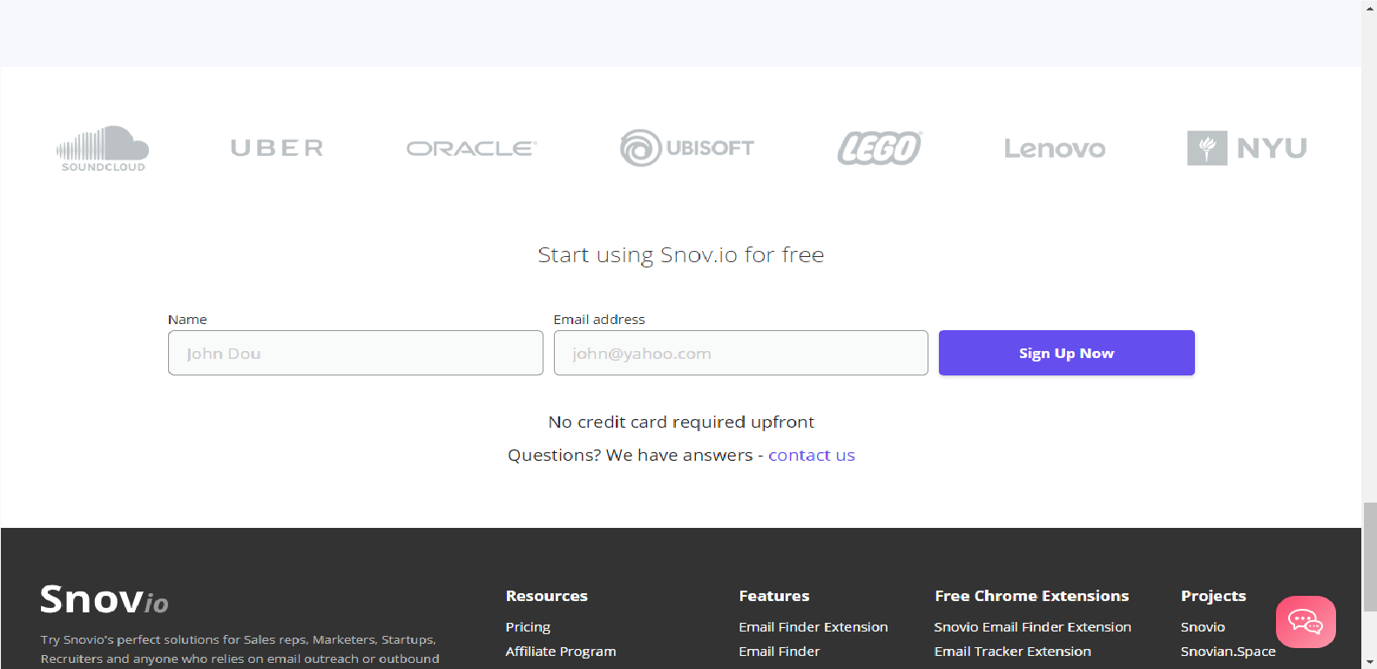

**Website Content**

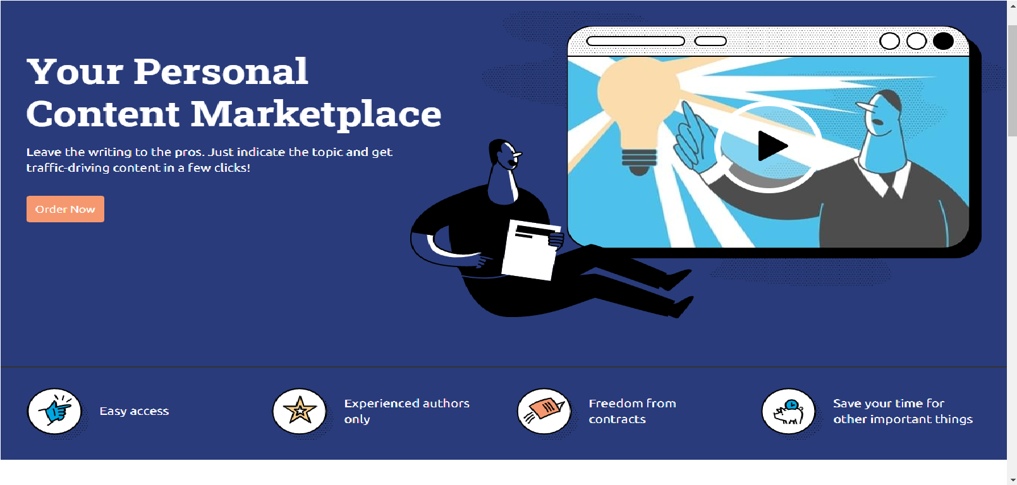

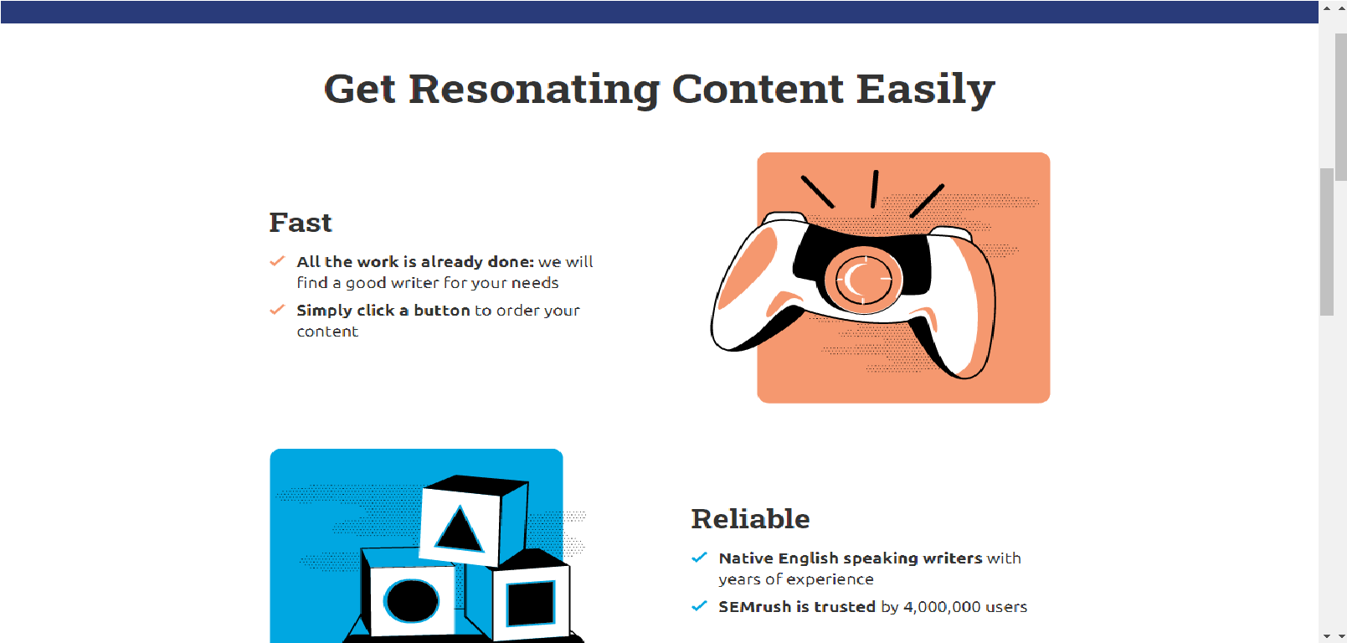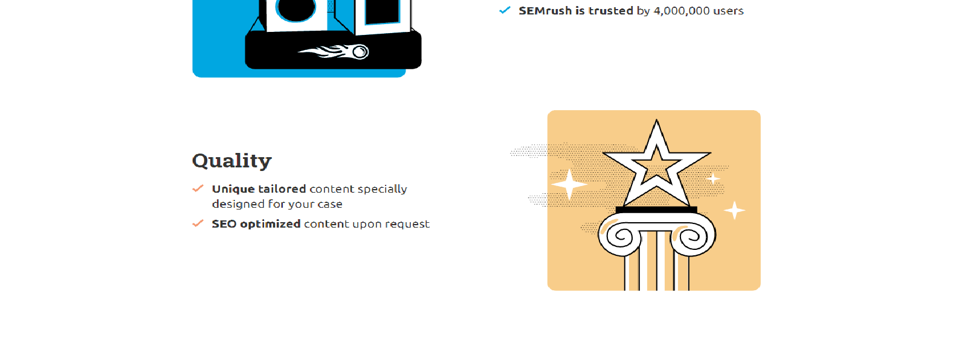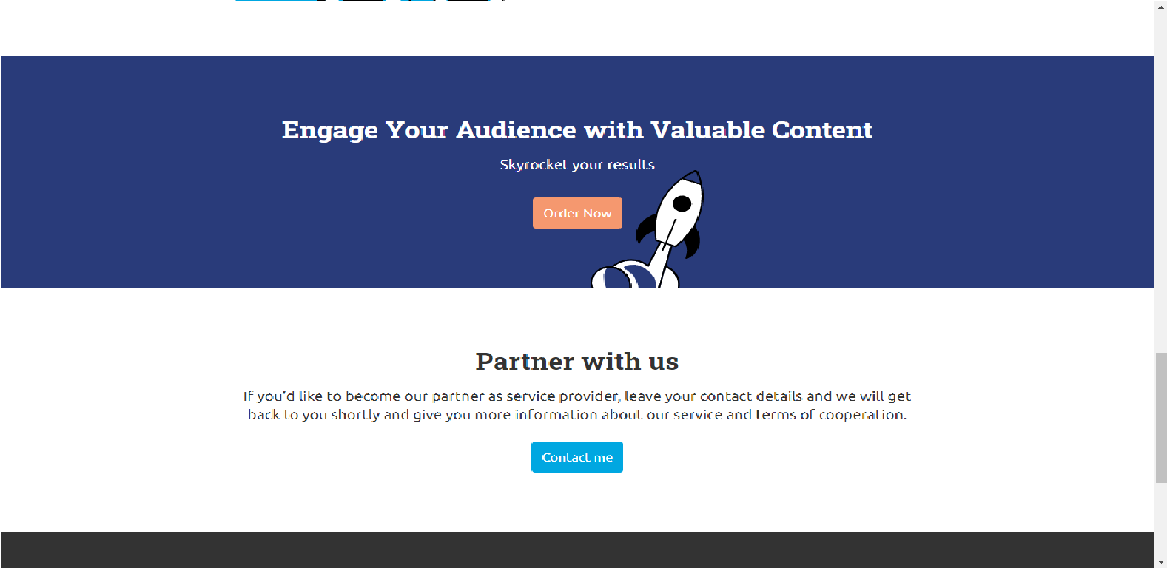

After Clicking on **Order Now Button**

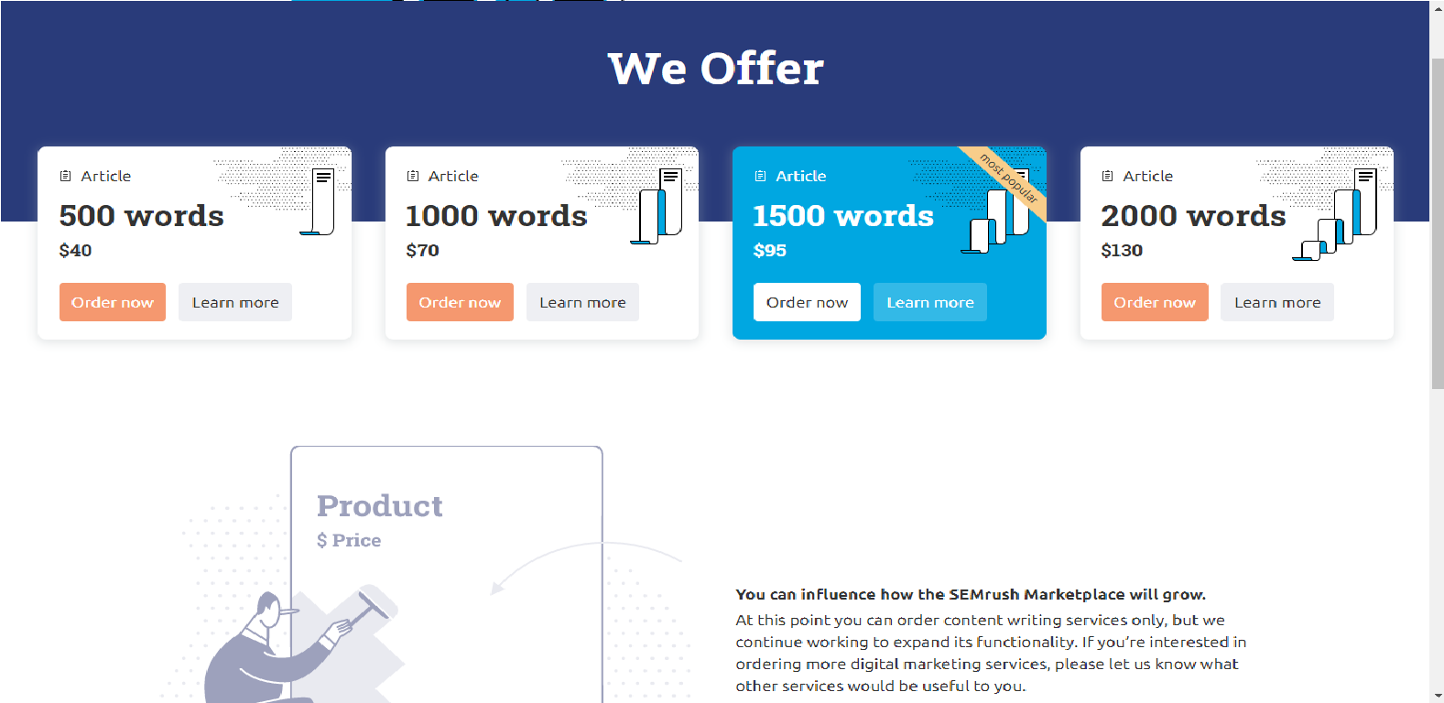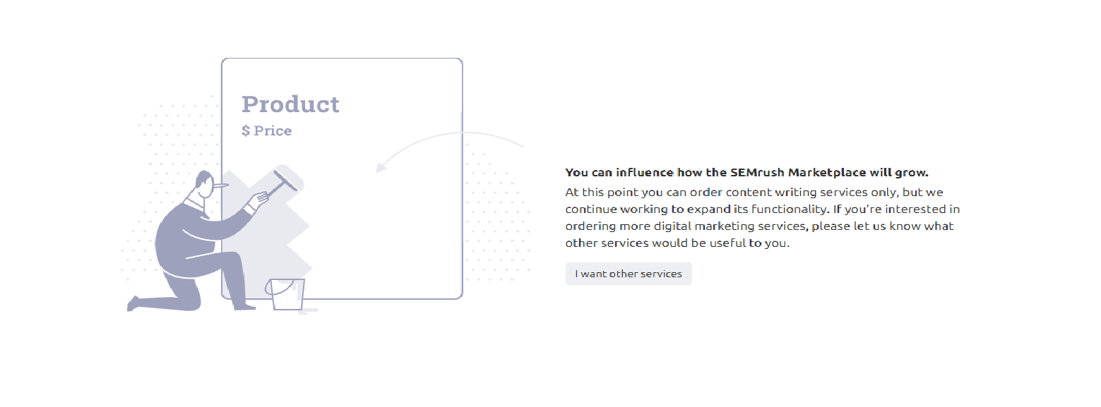

After Clicking on **Order Now**

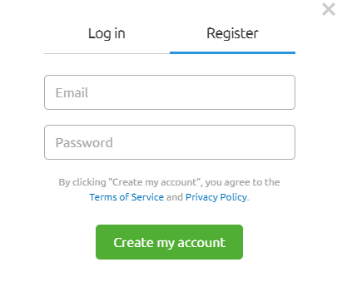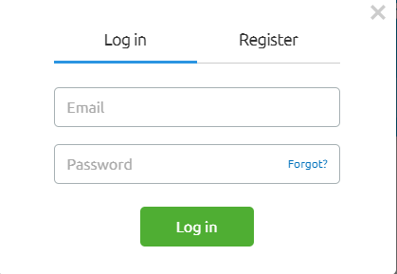

After Clicking on **Learn More**

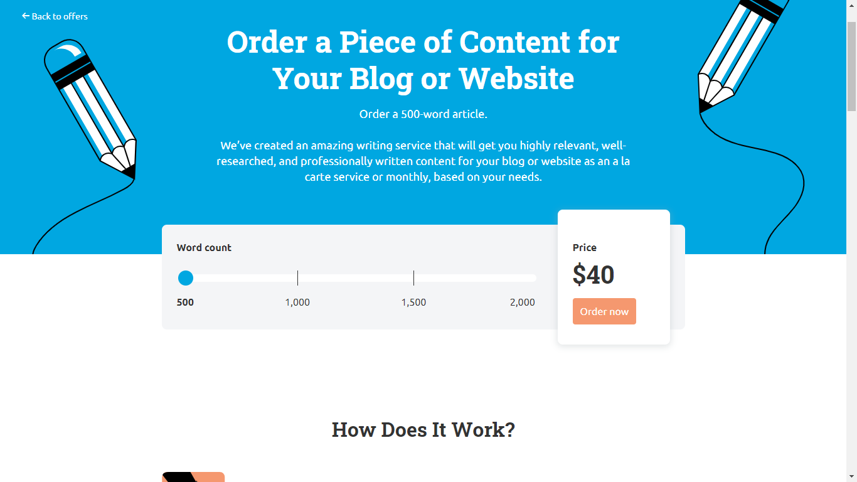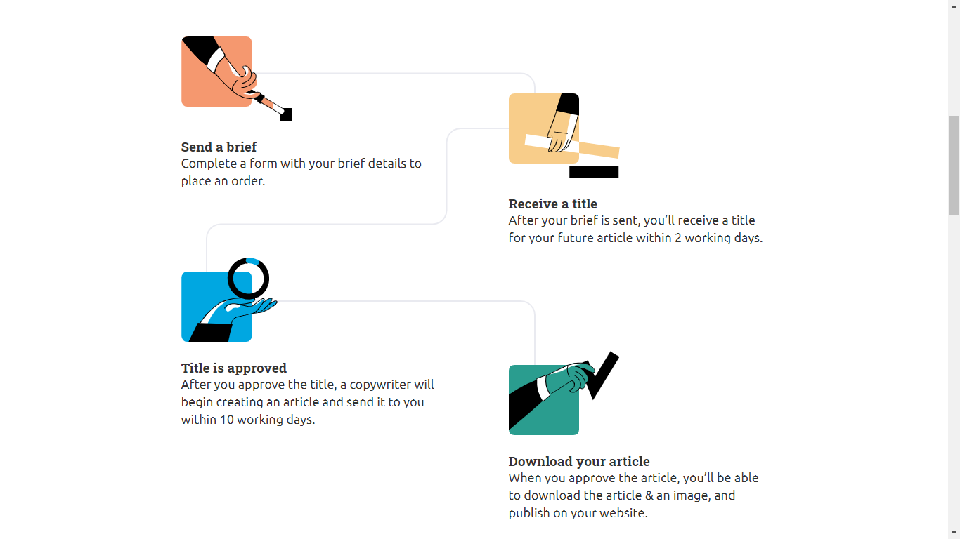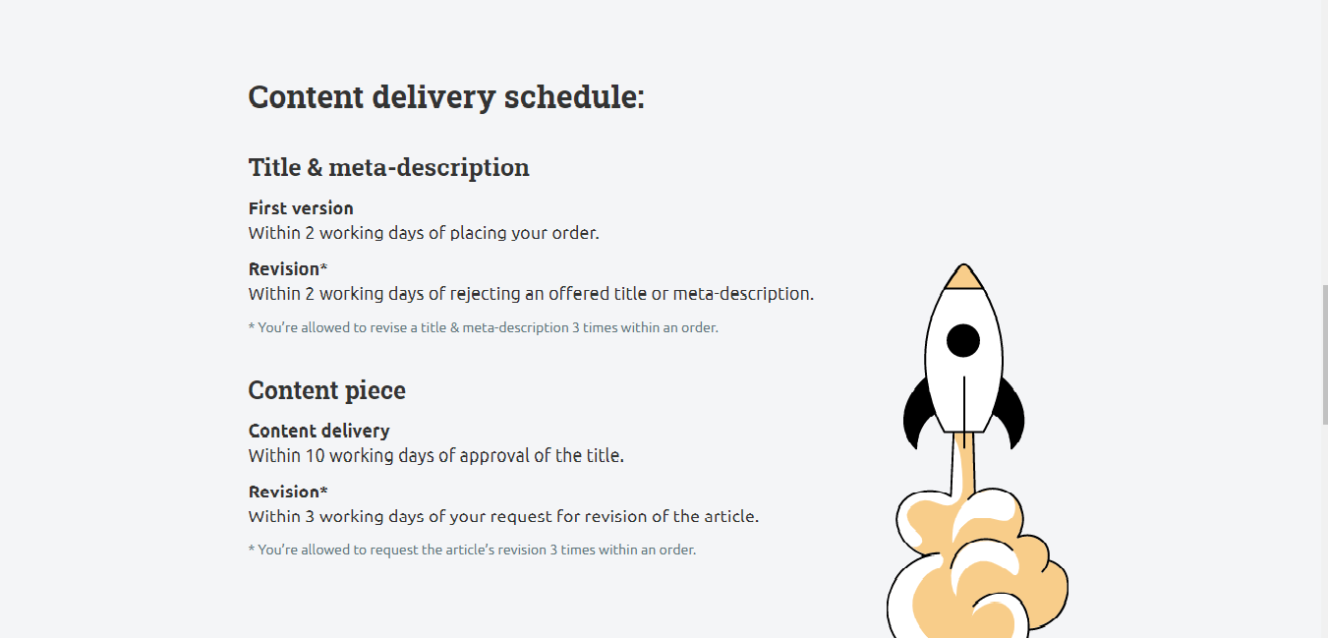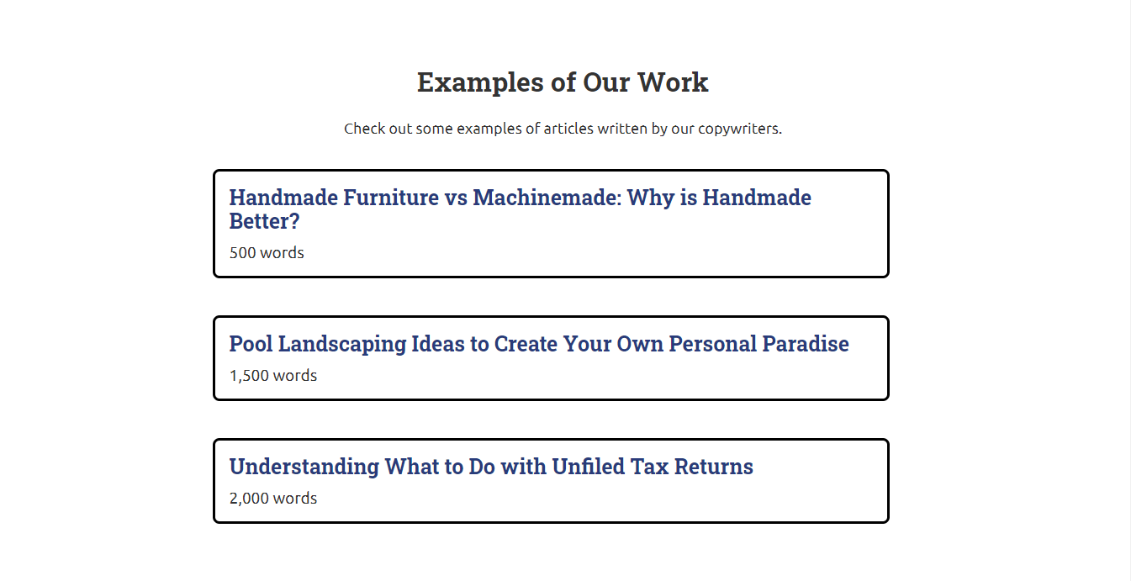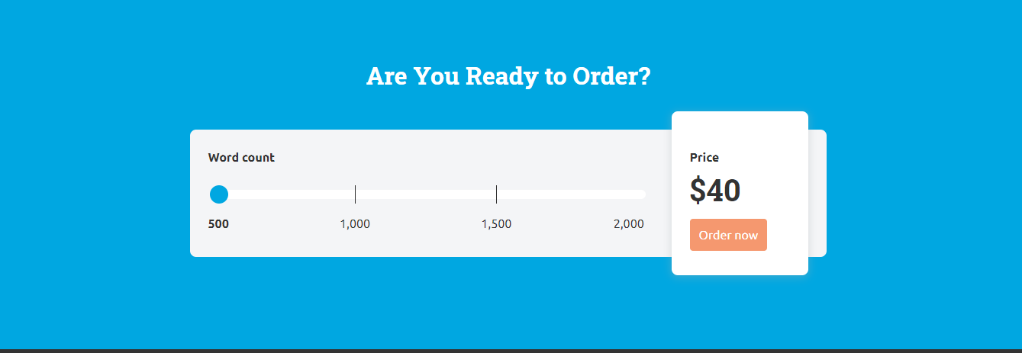

After Clicking on **I Want another Services**

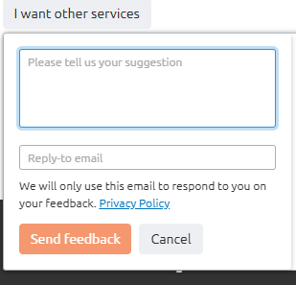

If any company want to collaborate with us and if he click on Contact me a model form will appear with the following fields

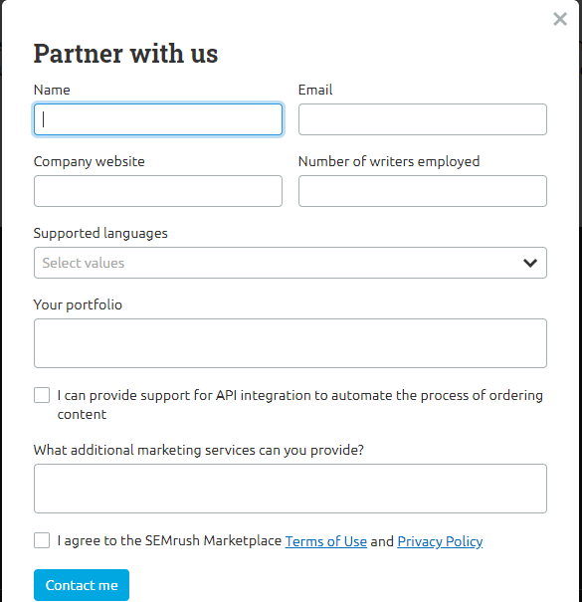

After Successful Registration if you click on Order Now a Model Will appear with following fields.

Also here they provide only four options Article 500 words, Article 1000 words, Article 1500 words, Article 2000 words and Rate is fixed. But we provide 12 options and the options are mentioned below;

|  |  |  |  |
| --- | --- | --- | --- |
| Article 500 Words | Rs 1 | Rs 500 | Option +1, 2,3,4,5 cost will change |
| Article 500 Words | Rs 2 | Rs 1000 |  |
| Article 500 Words | Rs 3 | Rs 1500 |  |
| Article 1000 Words | Rs 0.85 | Rs 850 |  |
| Article 1000 Words | Rs 1.85 | Rs 1850 |  |
| Article 1000 Words | Rs 2.85 | Rs 2850 |  |
| Article 1500 Words | Rs 0.75 | Rs 1,125 |  |
| Article 1500 Words | Rs 1.75 | Rs 2,625 |  |
| Article 1500 Words | Rs 2.75 | Rs 4,125 |  |
| Article 2000 Words | Rs 0.65 | Rs 1,300 |  |
| Article 2000 Words | Rs 1.65 | Rs 3,300 |  |
| Article 2000 Words | Rs 2.65 | Rs 5,300 |  |

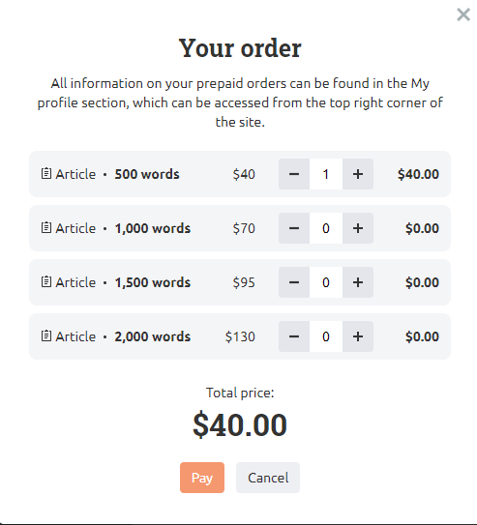

In Example of Our Work, After Clicking on Link a Model Will Pop up and contains the Content in the format of.

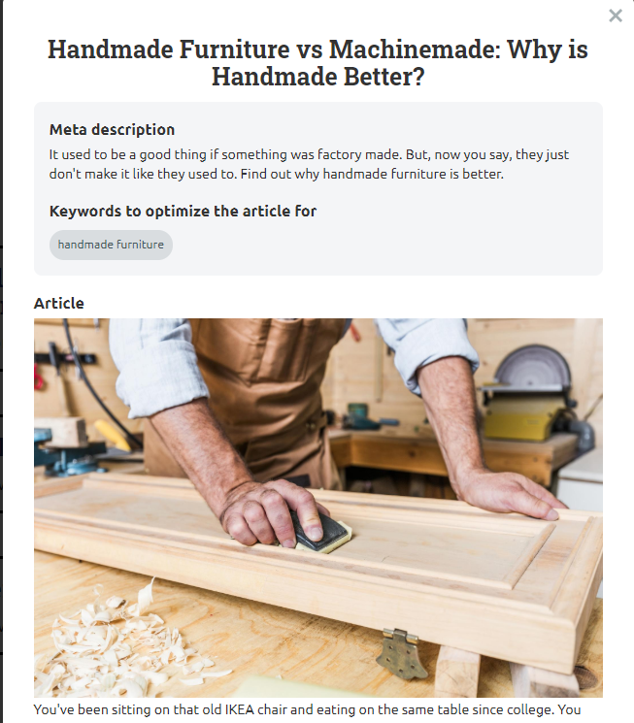

And below that a paragraph of content will appear

MARKETING DESIGNS PAGE

Banner

Banner Contains

G

<h2> Brochures and Posters </h2>

<p> Dummy Content </p>

Order List

* A
* A
* A
* A

Similarly for

* Case Studies & White Papers
* Landing Pages
* Presentations and Company Profile

Image Scroller

Image Scroller

<h2> Videos </h2>

<p> Dumy Content </p>

Order List

* A
* A
* A
* A

Image Scroller

<h2> Graphics and Images</h2>

<p> Dumy Content </p>

Order List

* A
* A
* A
* A

GET QUOTE

GET THE BEST MARKETING ASSETS

Need Branding. Get in Touch

KNOW MORE

Image

GROW YOUR BUSINESS WITH BETTER MARKETING DESIGNS

GET ENGAGE WITH US

**Footer**

CONTACT US

Now Call To Action Content

After Clicking on Know More Button it will Scroll down to the Content Section

After Clicking on **Need Branding. Get in Touch** Section a Model will appear with a form which Contains following fields Name, Email, Phone No, and Message.

After Clicking on Play Button a new page appear which the Gallery Page which contains Categories and Images of Designs according to the Category.

After Clicking on Get Quote a Model Form Will appear which contains following fields.

All Model Form contains the same form and the fields are mentioned below;

**Submit**

* Search Engine Optimization (SEO)
* Social Media Marketing (SMM)
* Search Engine Marketing (SEM)
* Email Marketing
* Graphic Designing
* UI/UX
* Website Development

This Section Contains a Drop Down with the list of Services.

Message:

Contact No:

Email:

Name: